C.AAA (Authentication, Authorization, Accounting): Three core functions, AAA in Networking &amp; Security, AAA Deployment Models.
Tasks
1.Write a short scenario where a user tries to access a private WiFi network (like at a campus or airport) and describe how each of the three AAA functions—Authentication, Authorization, and Accounting—would apply step by step in this situation.
A student named Rahul arrives at his university campus and wants to connect his laptop to the private campus WiFi network. He selects the WiFi network named CampusNet from the list of available wireless networks and enters his university username and password. The network then checks the credentials against the university's authentication server. If the username and password are correct, Rahul's identity is verified and he is allowed to proceed. This process is known as Authentication, which answers the question, "Who are you?"
After Rahul is successfully authenticated, the network determines what resources and services he is allowed to access. Since he is a registered student, he is granted access to the internet, online learning platforms, digital library resources, and student portals. However, he is not allowed to access administrative systems that are reserved for faculty and staff. This process is called Authorization, which answers the question, "What are you allowed to do?"
Once Rahul begins using the network, the system records details of his connection, including the time he logged in, the duration of his session, the amount of data used, and the websites or services accessed. These records can be used for network monitoring, troubleshooting, security investigations, and usage reporting. This process is known as Accounting, which answers the question, "What did you do while connected?"
2.Create a table comparing at least two different AAA deployment models (such as centralized vs distributed), listing three advantages and three disadvantages of each for a company like Zomato that handles sensitive user data.

Aspect |  | Centralized AAA Model | Distributed AAA Model
Definition |  | All Authentication, Authorization, and Accounting services are managed by a single central server. | AAA services are managed by multiple servers located in different regions or locations.
Authentication |  | User credentials are verified by one central AAA server. | Users are authenticated by the nearest or designated AAA server.
Authorization |  | Access permissions are controlled from a central location. | Access permissions are managed across multiple servers and synchronized.
Accounting |  | All user activity logs are stored in one central database. | User activity logs are collected from multiple servers and may be aggregated.
Advantages |  | 1. Easier administration.2. Consistent security policies.3. Simpler auditing and reporting. | 1. Higher availability.2. Better performance for geographically distributed users.3. Improved scalability.
Disadvantages |  | 1. Single point of failure.2. Higher latency for remote users.3. Limited scalability. | 1. More complex management.2. Higher deployment cost.3. Risk of policy inconsistencies between servers.
Security |  | Easier to enforce uniform security policies. | More resilient but requires synchronization of security policies.
Best Use Case |  | Small to medium-sized organizations with a single location. | Large enterprises with multiple offices and global operations.

AAA Deployment Model |  | Advantages (for Zomato) | Disadvantages (for Zomato)
Centralized AAA |  | 1. Easier Management: All user accounts, permissions, and logs are managed from one location.2. Consistent Security Policies: The same authentication and authorization rules apply to all users and employees.3. Simplified Auditing: User activity logs are stored centrally, making security monitoring and compliance easier. | 1. Single Point of Failure: If the central AAA server fails, users may be unable to access services.2. Higher Latency: Users far from the central server may experience slower authentication responses.3. Limited Scalability: As Zomato's user base grows, the central server may become overloaded.
Distributed AAA |  | 1. High Availability: If one AAA server fails, other servers can continue providing authentication services.2. Better Performance: Users are authenticated by the nearest server, reducing response time.3. Improved Scalability: Additional AAA servers can be added to support increasing numbers of customers and employees. | 1. Complex Management: Multiple servers require careful administration and synchronization.2. Higher Cost: More hardware, software, and maintenance resources are needed.3. Risk of Inconsistent Policies: Security rules and user data may become inconsistent if synchronization fails.
3.Draw a simple network diagram (can be hand-drawn and photographed) showing how AAA servers are integrated into a typical enterprise network for user access control, labeling where Authentication, Authorization, and Accounting processes happen.
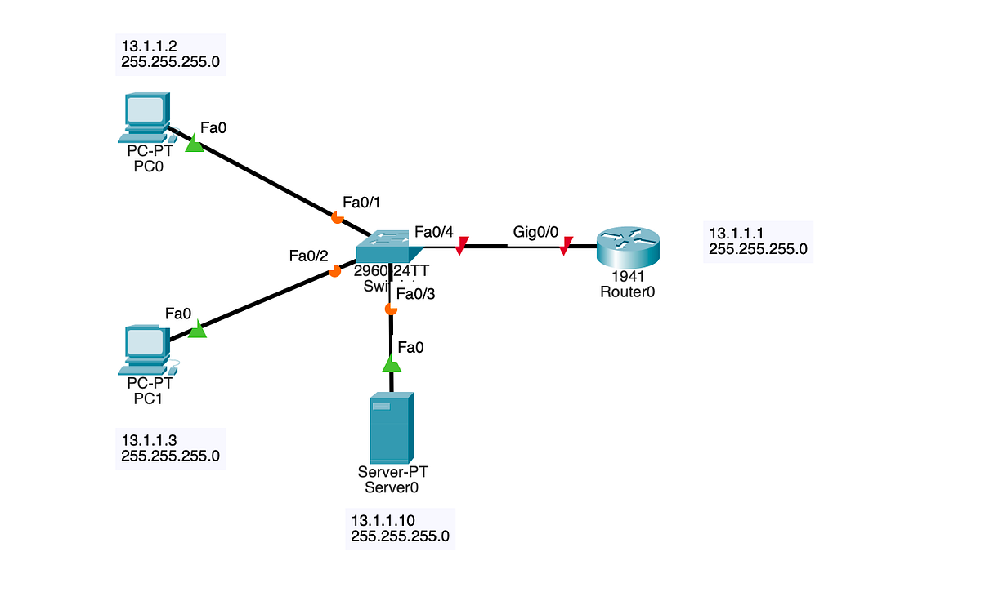
This network topology represents a simple enterprise network in which two client computers (PC0 and PC1) and an AAA Server (Server0) are connected to a switch, which is then connected to a router. All devices belong to the same network 13.1.1.0/24. PC0 has the IP address 13.1.1.2, PC1 has 13.1.1.3, the AAA Server has 13.1.1.10, and the router interface (Gig0/0) has 13.1.1.1, which acts as the default gateway for the network. When a user on PC0 or PC1 attempts to access network resources, the request is sent through the switch to the AAA Server. The AAA Server performs Authentication by verifying the user's username and password. After successful login, it performs Authorization by determining what resources and services the user is permitted to access based on their role or permissions. Finally, the AAA Server performs Accounting by recording information such as login time, logout time, session duration, and network usage. The router provides connectivity to other networks or the internet, while the AAA Server ensures that only authorized users gain access and that all user activities are logged for security and auditing purposes. This architecture is commonly used in enterprise environments to improve security, control access to resources, and maintain detailed records of user activity.
4.Pick any app you use daily (Instagram, Paytm, or Flipkart) and write a paragraph explaining how AAA concepts could be applied to secure user logins and actions within that app.Hint: Think about what happens when you log in, what features you are allowed to use, and how your actions might be tracked for security or billing.
Instagram uses the AAA (Authentication, Authorization, and Accounting) model to secure user accounts and activities. When a user opens Instagram and enters their username, email, or phone number along with a password, Instagram verifies these credentials before allowing access to the account. This process is called Authentication. In some cases, Instagram may also send an OTP or require Two-Factor Authentication (2FA) for additional security.
After the user successfully logs in, Instagram determines what actions they are permitted to perform. For example, a normal user can upload photos, create stories, send messages, follow other users, and edit their profile, but cannot access Instagram's internal administration systems. This process is known as Authorization because it controls the level of access granted to the user.
Instagram also keeps records of user activities such as login times, devices used, posts uploaded, comments made, likes, follows, and account setting changes. These records help detect suspicious activity, investigate security incidents, and improve platform security. This process is called Accounting. Together, Authentication, Authorization, and Accounting help Instagram protect user accounts, control access to features, and maintain a secure environment for millions of users.
5.Use ChatGPT or any AI tool to generate a sample AAA policy for a college WiFi network that restricts access to students only, allows certain websites, and logs all access attempts. Paste the generated policy and briefly explain how each AAA function is addressed.
College WiFi AAA Policy
Policy Name: Student WiFi Access Policy
Purpose:
To provide secure internet access to authorized students while protecting college network resources and maintaining activity logs for security and auditing purposes.
Authentication Policy:
- Only registered students with a valid college username and password may access the WiFi network.
- Users must authenticate through the college authentication server before gaining network access.
- Failed login attempts exceeding five times will result in temporary account suspension.
- Multi-factor authentication (MFA) may be required for additional security.
Authorization Policy:
- Authenticated students are granted access to educational websites, online learning platforms, email services, and approved academic resources.
- Access to unauthorized, malicious, or restricted websites is blocked.
- Administrative systems and staff-only resources are not accessible to students.
- Network bandwidth may be limited per user to ensure fair usage.
Accounting Policy:
- All login attempts, successful or unsuccessful, are recorded.
- User activities such as login time, logout time, IP address, session duration, and data usage are logged.
- Security logs are retained for one year for auditing and investigation purposes.
- Network administrators may review logs to detect misuse or security threats.

